Project 2 Proposal

Members:

Robin Christoffersen

Jacob Concha

Carmela Monis

This project’s topic is mass shootings that have occurred in the United States from 1982 to May 2021. One reason we chose this topic is because gun violence and mass shootings have been on the rise in recent years. According to the Washington Post, 2020 was the deadliest gun violence year in decades. So far, 2021 is worse.1 They significantly affect the communities they take place in and society in whole.

From a Mother Jones CSV file containing 124 records, we seek to create interactive and informative visualizations for the user. Our data set was found on data.world and can be found here: <https://data.world/awram/us-mass-shootings>.

Inspiring screenshots:

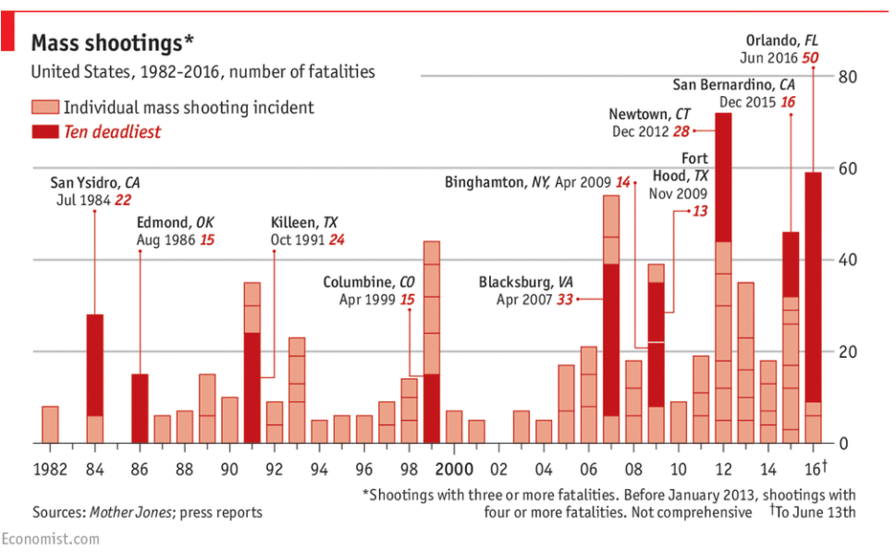 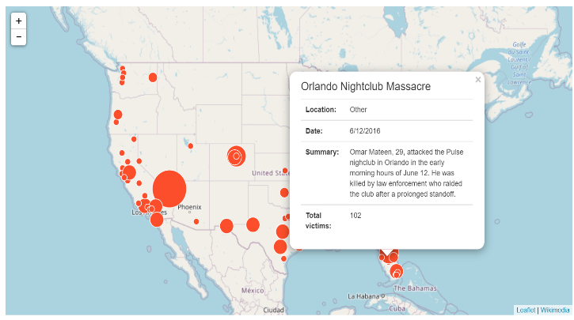

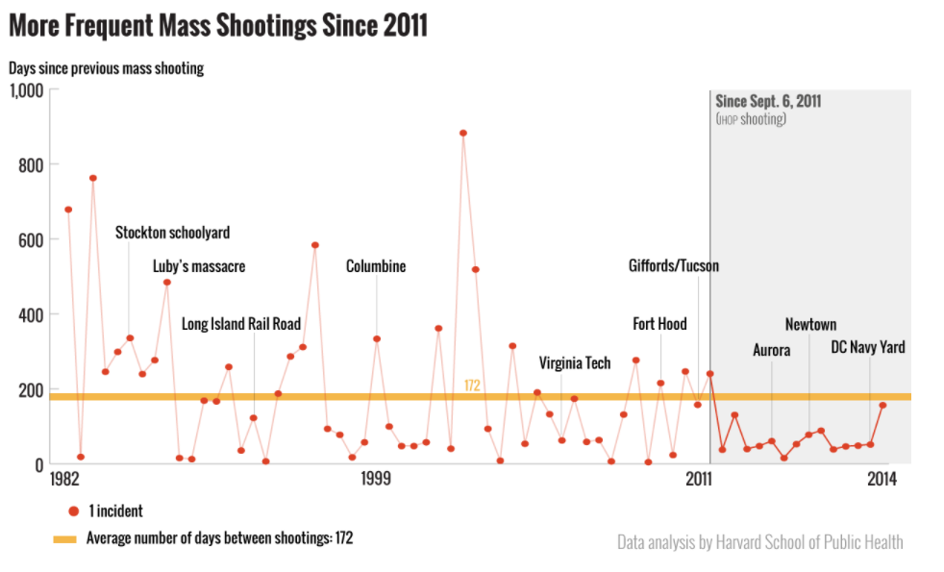 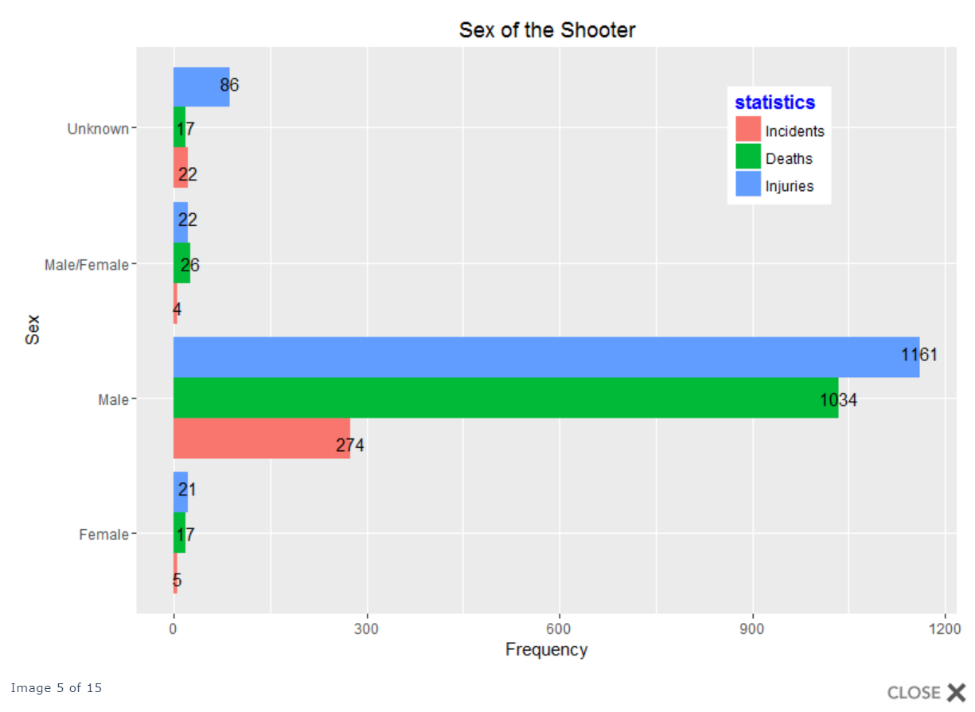

Link to GitHub repository: <https://github.com/RobinWaves/Project-2>

1 <https://www.washingtonpost.com/nation/2021/06/14/2021-gun-violence/>